**Mod 4: Critical Thinking**

Alex Mehler

CSU Global

CSC372-1

Dr. Coope

April 13, 2024

**Execution:**

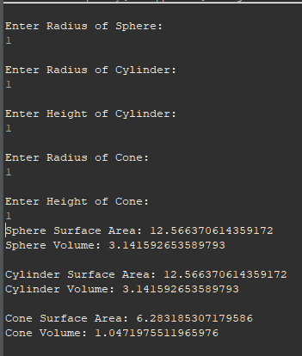

**UML:**

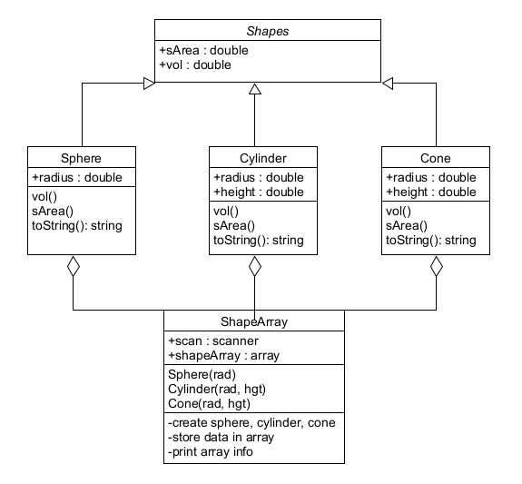

**Code:**

**Shapes:**

abstract public class Shapes{

abstract double sArea();

abstract double vol();

}

**Sphere:**

public class Sphere extends Shapes{

double radius;

Sphere(double rad){

radius = rad;

}

*@Override*

double sArea() {

// area formula

return 4*Math.***PI***\*Math.*pow*(radius, 2);

}

*@Override*

double vol() {

// volume formula

return (4/3)*Math.***PI***\*Math.*pow*(radius, 2);

}

public String toString() {

String outPut = "";

outPut = outPut + "Sphere Surface Area: " + sArea()+ "\n";

outPut = outPut + "Sphere Volume: " + vol()+ "\n";

return outPut;

}

}

**Cylinder:**

public class Cylinder extends Shapes{

double radius;

double height;

Cylinder(double rad, double hgt){

radius = rad;

height = hgt;

}

*@Override*

double sArea() {

// area formula

return (2*Math.***PI***\*radius*height)+(2*Math.***PI***\*Math.*pow*(radius, 2));

}

*@Override*

double vol() {

// volume formula

return Math.***PI***\*Math.*pow*(radius, 2)*height;

}

public String toString() {

String outPut = "";

outPut = outPut + "Cylinder Surface Area: " + sArea()+ "\n";

outPut = outPut + "Cylinder Volume: " + vol()+ "\n";

return outPut;

}

}

**Cone:**

public class Cone extends Shapes{

double radius;

double height;

Cone(double rad, double hgt){

radius = rad;

height = hgt;

}

*@Override*

double sArea() {

// area formula

return (Math.***PI***\*radius)*(radius+(Math.*sqrt*(Math.*pow*(height, 2)*Math.*pow*(radius, 2))));

}

*@Override*

double vol() {

// volume formula

return (Math.***PI***\*Math.*pow*(radius, 2))*(height/3);

}

public String toString() {

String outPut = "";

outPut = outPut + "Cone Surface Area: " + sArea()+ "\n";

outPut = outPut + "Cone Volume: " + vol()+ "\n";

return outPut;

}

}

**Shape Array:**

import java.util.Scanner;

public class ShapeArray {

public static void main(String[]args) {

double rad;

double hgt;

//start scanner

Scanner scan = new Scanner(System.***in***);

Shapes[]shapeArray = new Shapes[3];

//make sphere

System.***out***.println("\nEnter Radius of Sphere: ");

rad = scan.nextDouble();

Sphere sphere = new Sphere(rad);

shapeArray[0] = sphere;

//make cylinder

System.***out***.println("\nEnter Radius of Cylinder: ");

rad = scan.nextDouble();

System.***out***.println("\nEnter Height of Cylinder: ");

hgt = scan.nextDouble();

Cylinder cylinder = new Cylinder(rad,hgt);

shapeArray[1] = cylinder;

//make cone

System.***out***.println("\nEnter Radius of Cone: ");

rad = scan.nextDouble();

System.***out***.println("\nEnter Height of Cone: ");

hgt = scan.nextDouble();

Cone cone = new Cone(rad,hgt);

shapeArray[2] = cone;

//short list, no need for loops

System.***out***.println(shapeArray[0]);

System.***out***.println(shapeArray[1]);

System.***out***.println(shapeArray[2]);

scan.close();

}

}

**Git:**

https://github.com/SevRnce/